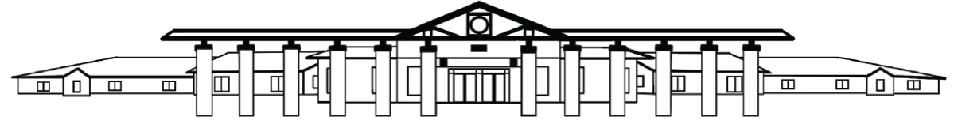

PICK ELEMENTARY SCHOOL 2024-2025

Family Engagement Plan

Pick Elementary School is committed to partnering with families and maintaining strong connections to support the success of our students. Research indicates that parent involvement is a key indicator to a child’s success, and we are proud to offer numerous opportunities to foster this involvement throughout the school year. Opportunities for this academic year include but are not limited to:

* Meet Your Teacher
* Curriculum Night
* Title 1 Annual Meeting and Parent Resource Fair
* Parent resource and information sessions
* PTO meetings
* Student-led conferences
* Parent-Teacher conferences
* Programs and student presentations
* Book fairs
* Field trips
* Classroom visits
* Classroom volunteers
* STEM Night

Our commitment to ongoing, open communication between home and school will include contacts through:

* Personal phone calls, emails, and written notes
* Classroom newsletters
* PES school newsletters
* Flyers for upcoming events
* School and classroom websites
* Notes in student planners
* Classroom communication folders
* Social Media messages
* Digital video links
* Blackboard Schoolwide Communication messages via text, email, and voice recordings

All families will receive the school and district engagement plans and the school compact annually. We value your input, and we will request it through surveys, meetings, and conferences. Please reach out to us if you have any questions and to let us know how we can support you and your child. Thank you for your support and teamwork!

1320 North College Street, Auburn, AL 36830 p.334.887.2110 f.334.8876057 https://www.auburnschools.org/pes

